KMC Hackathon Project Report

Project Title: Anti-Bullying Website

Team Name: Stand Strong
Team Members: Pratyush Gyawali, Abhiyan Gautam, Sugat Maharjan
Mentor: ____________________

1. Abstract
Bullying is a very common problem in our classrooms. Our project presents a website from which students can report others if they get bullied from someone. The information is directly saved into a database which the teachers and in-charges can access.

2. Problem Statement
Many people get bullied in different places like inside classroom outside classroom etc. Teachers need to take quick action.

3. Existing System
Students rarely report bullies as they are scared that they might get teased and bullied again. This process is very unreliable and not many people so it.

4. Proposed Solution
We developed an Anti-Bullying website where student can report bullies. Student give their and bullies information which is saved in a database. Teachers can view that database base and take actions instantly.

5. Objectives
• Minimize the amount of bullies.
• Maintain the record of bullying.
• Provide easy access to the data.

6. Technology Used
Frontend: HTML, CSS
Backend: JavaScript
Database: Firebase
Devices: Laptop

7. Results
After testing, the time to report bullies was very simple and fast. Records became fully digital and easy to access.

8. Advantages
• Helps introvert report bullies as some might be sacred to talk to the teacher.
• Accurate data.
• Easy to punish the culprit.

9. Limitations
• Requires internet connection.
• Students need access to a device.

10. Conclusion

The Anti-Bullying website provides separate dashboards for students and teachers to promote a safer school environment. Students can report bullying, and teachers can review and manage reports.

11. System Wireframe

Figure 1:- Login page wireframe:
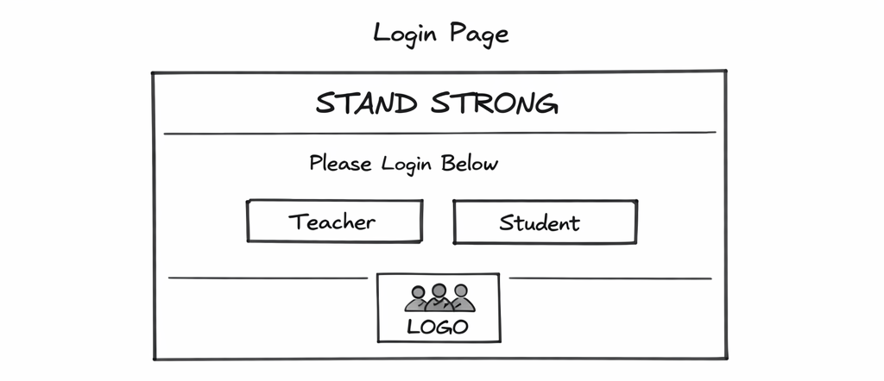

Figure 2:- Student page wireframe:

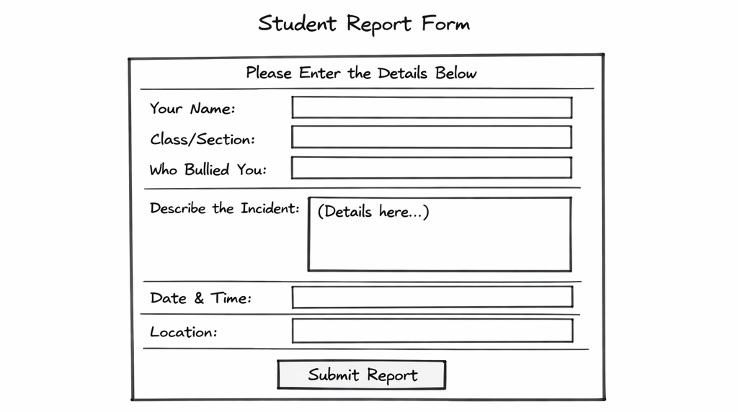

Figure :- Teacher page wireframe:

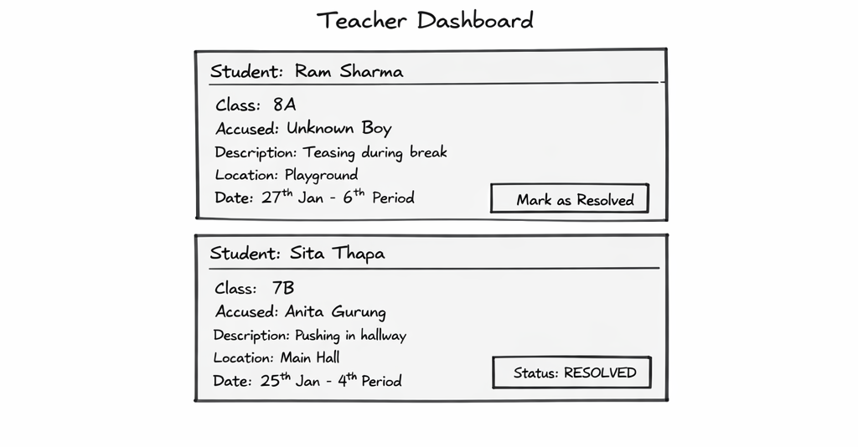

12. System Workflow

Figure 4:- Workflow diagram:

